**GUIA PEDAGÓGICA N° 15**

**PLAN DE APRENDIZAJE REMOTO**

|  |  |  |  |
| --- | --- | --- | --- |
| **Nombre del estudiante:** |  | | |
| **Profesor(a):** | **Paola Véliz Herrera** | | |
| **Correo electrónico** | **paolaveliz.jlp@gmail.com** | **Puntaje total:** | **65 puntos.** |
| **Curso:** | **8° Básico** | **Asignatura:** | **Inglés** |
| **Fecha de envío:** | **30/10/2020** | **Fecha de recepción:** | **30/11/2020** |

|  |  |
| --- | --- |
| **Unidad N° 4** | **Future matters** |
| **Objetivo/s general/es:**  **OA1 - OA12 - OA14** | **Global issues, technology and environment**   * Demostrar conocimiento y uso del vocabulario aprendido * Dan información general sobre un tema conocido. * Recuentan en forma breve alguna idea relevante de narraciones o anécdotas escuchadas. * Identifican información específica al hacer una lectura focalizada del texto. |
| **Instrucciones** | * Respetar la fecha de entrega para las actividades. * Cualquier duda, enviar un correo electrónico a la docente. * Necesitará lápices, hojas en algunos casos, y **diccionario**, ya sea en línea o físico. |

1. 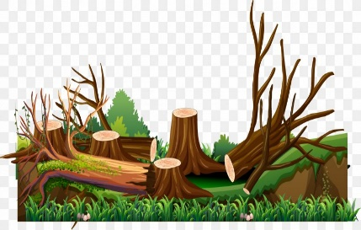**Global Issues: Look at the image and circle the right answer**. Problema global: Observa la imagen y encierra en un círculo la alternativa correcta. (**15 points)**
2. **Deforestation**
3. **Oil spill**
4. **Exploitation**

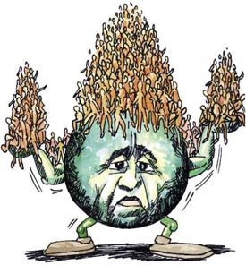

1. **Terrorism**
2. **Over fishing**
3. **Overpopulation**

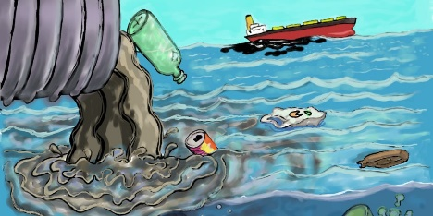

1. **Exhaust fumes**
2. **Land fill**
3. **River pollution**
4. 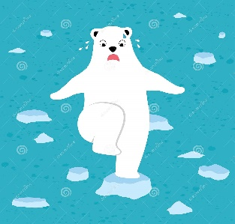
5. **Child labour**
6. **Ice cap melting**
7. 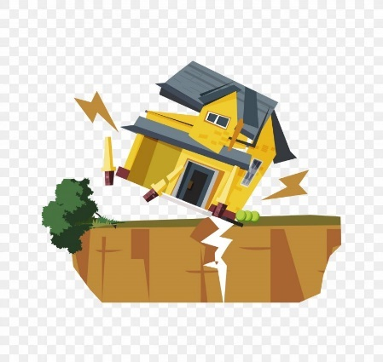**Plastic pollution**
8. **Famine**
9. **Civil war**
10. **Earthquake**

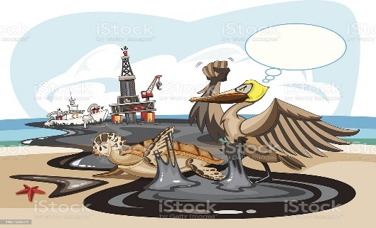

1. **Oil spill**
2. **Deforestation**
3. 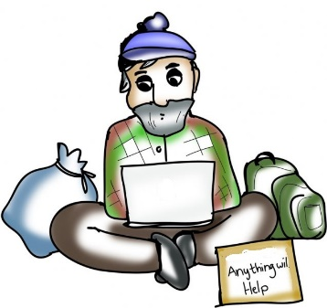**Acid rain**
4. **Drought**
5. **Extinction**
6. **Homelessness**

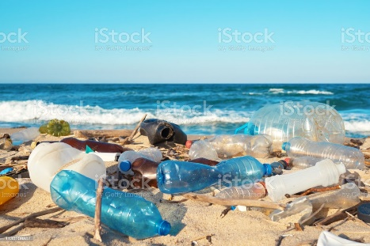

1. **Avalanche**
2. 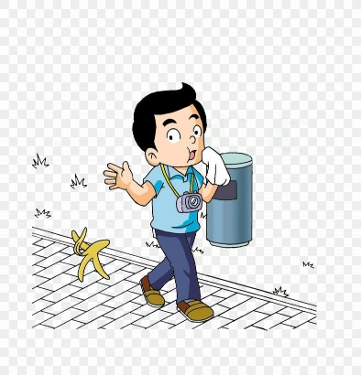**Plastic pollution**
3. **Climate change**
   1. **volcano**
   2. **landslide**
   3. **littering**
4. 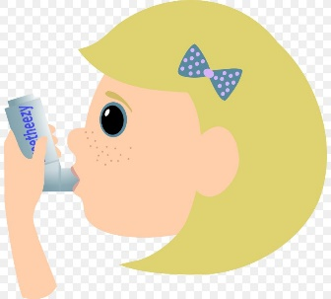
5. **Consumerism**
6. **Over farming**
7. **Asthma**

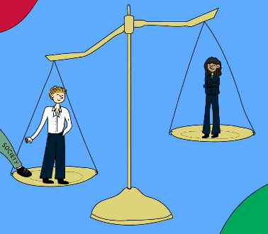

1. **Racism**
2. **Sexism**
3. **Homophobia**

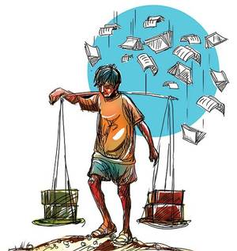

1. **Ozone depletion**
2. **Nuclear waste**
3. **Child labour**

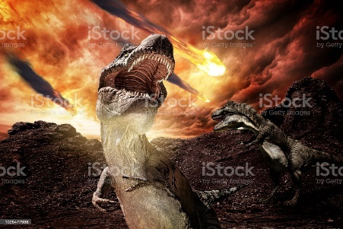

1. **Extinction**
2. **Slavery**
3. **Over fishing**

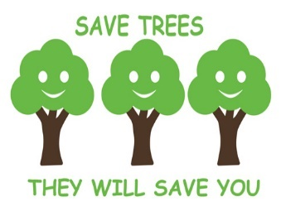

1. **Walk in the park**
2. **Protect green spaces**
3. **Climb trees**

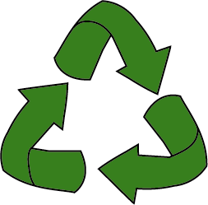

1. **Cycle to work**
2. **Re-use and recycle**
3. **Eat more meat**
4. **Vocabulary: Translate each word into Spanish.** Vocabulario: Traduce las siguientes palabras al español utilizando tu diccionario. **Con letra clara escribe los nombres en español *(6 points)***

|  |  |
| --- | --- |
| **English** | **Spanish** |
| 1. **Water crisis:** |  |
| 1. **Terrorism:** |  |
| 1. **Corruption:** |  |
| 1. **Overfishing:** |  |
| 1. **Food crisis:** |  |
| 1. **Protect green spaces:** |  |

1. **Global problems: Read each word and write them under each image.** Problemas globales: Lee cada palabra del recuadro y escríbelas bajo la imagen que corresponda, puedes ayudarte con el diccionario. ***(8 points)***



1. **Water crisis**
2. **Income inequality**
3. **Terrorism**
4. **Global warming**
5. **Corruption**
6. **Urbanisation and overpopulation**
7. **Food crisis**
8. **Overfishing**

1)___________________

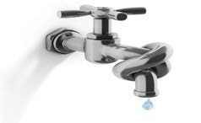

2)___________________________

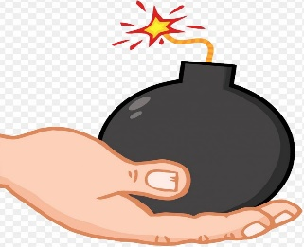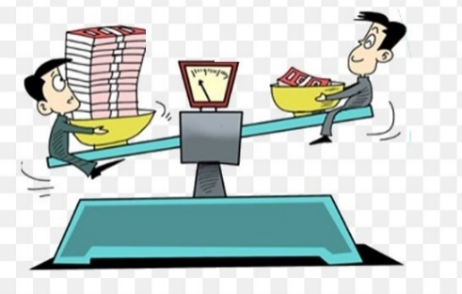

3)________________________________ 4)________________________________

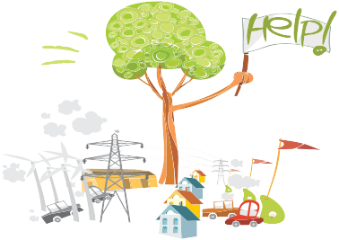

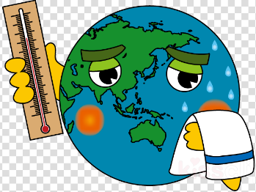

5)________________________________ 6)________________________________

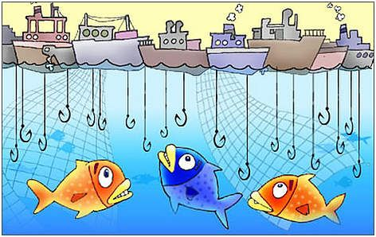

7)________________________________ 8)________________________________

**Listening** [**https://drive.google.com/file/d/12qHD6xwT7CkcxDLZ0YlS6uFZeT701vUs/view?usp=sharing**](https://drive.google.com/file/d/12qHD6xwT7CkcxDLZ0YlS6uFZeT701vUs/view?usp=sharing)

**Technology: Samsung Shows Off New Foldable Phone.**

1. **Listen to the recording and complete the sentences with the**

**words from the box**. Escucha el audio y completa las partes faltantes utilizando las palabras del recuadro. El audio se adjuntará en el enlace de drive que aparece arriba. (**14 points)**

experience - mobile - device – revolutionary - designed - tablet - flexible

**a.** The phone is _____________________ to fold open to make the ____________ the size of a small tablet.

**b.** “Ladies and gentlemen, I give you the future of ___________________ display.

**c.** “…When it’s open, it’s a _________________________, offering a big screen _______________…”

**d.** He said one of the biggest difficulties was finding a material that was ________.

**e.** Technology experts see the new foldable design as a way to get users to buy a new device seen as _______________________________.

**Writing**

1. **How much time do you spend on your cell phone? Fill in the blanks your answer**. ¿Cuánto tiempo utilizas tu celular? Completa en cada línea el tiempo que sueles utilizar tu celular. **(5 points)**

* **Ejemplo**: Listen to music: I usually use my phone two to four hours.



**a.** Listening to music: ________________________ hours.

**b.** Talking: ________________________ hours.

**c.** Texting: ________________________ hours.

**d.** Playing games: ________________________ hours.

**e.** Watching TV: ________________________ hours.

It's always good to be aware of certain environmental concerns. We all live on this planet and have to take care of it.

1. **Environmental concerns: Read each sentence and circle the right answer**. Preocupación medioambiental: Lee cada oración y encierra en un circulo la alternativa correcta, puedes ayudarte utilizando tu diccionario para buscar el significado de las palabras. **(9 points)**

**1. Exhaust fumes cause a lot of ________, especially in big cities.**

a) Recycling  
b) Pollution  
  
**2. Everyone should learn to ________ ( = save) energy. Using lights/lamps only when needed is a good way to do this.**

a) Conserve  
b) Converse  
  
**3. Nancy is ________ about pollution. This is why she walks to work instead of driving.**

a) Cornered  
b) Concerned  
  
**4. ________ is much healthier than driving, and it doesn't pollute the air.**

a) Baking  
b) Biking  
 **5. David conserves water by not letting it ________ when he’s not using it.**

a) Run  
b) Eat  
  
**6. I’d like to conserve water... But I feel dirty if I don’t ________ three times a day!**

a) Bath  
b) Shower  
  
**7. Many unethical companies ________ their waste into rivers.**

a) Dump  
b) Give  
  
**8. ________, which is partly caused by exhaust fumes from cars, is a very big problem in many big cities across the world.**

a) Smog  
b) Smoke  
  
**9. ________ rain occurs when pollution in the air is absorbed by water droplets in clouds.**

a) Dirty  
b) Acid

1. **Reading comprehension: Read and circle the right answer**. Comprensión de lectura: Lee y encierra en un círculo la alternativa correcta. **(8 points)**

**A POLLUTED WORLD**

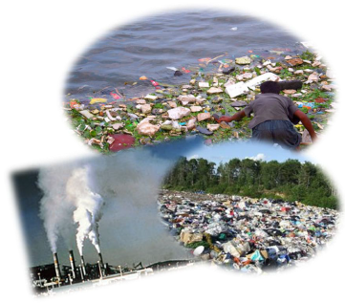The environment has been polluted in many different ways. The three major ways are water, land and air pollution.

 Water pollution is the contamination of lakes, caused by human activities. It can be harmful to organisms and plants which live in the water. Water pollution occurs when wastes are discharged from waste water treatment plants. Other known causes are factory wastes or leaking underground tanks. These can be chemical substances that are toxic. The polluted water can cause cholera and typhoid fever. Water pollution has led to the deaths of more than 14,000 people daily.

                Land pollution is the destruction of the earth’s land surfaces. ***It*** is often caused by human activities such as careless disposal of wastes, over-mining of minerals and wrong use of land for planting. All these will affect our health in the long run. They will lead to all kinds of diseases such as cancer, heart disease and breathing problems. Land pollution also brings about natural disasters such as flash floods and landslides.

                Air pollution is also the result of human activity where chemicals and other dangerous materials are released into the air. High air pollution levels can cause damage to the environment. It also brings discomfort to humans and other living organisms. In the long term, air pollution can cause serious breathing problems, lung cancer and heart disease.

**1. How many ways is the environment being polluted?**

* 1. Two
  2. Three
  3. Four
  4. Five

**2. What type of diseases caused by polluted water?**

1. Cholera and typhoid fever
2. Breathing problems and cancer
3. Heart disease and typhoid fever
4. Cholera and breathing problems

**3. The word *It* in the passage refers to the**

1. diseases
2. land pollution
3. air pollution
4. water pollution

**4. Which of the following causes land pollution?**

1. Toxic factory wastes
2. Over-mining of minerals
3. Burning of coal and oil
4. Leaking underground tanks