**GUIA PEDAGÓGICA N° 15**

**PLAN DE APRENDIZAJE REMOTO**

|  |  |  |  |
| --- | --- | --- | --- |
| **Nombre del estudiante:** |  | | |
| **Profesor(a):** | **Paola Véliz Herrera** | | |
| **Correo electrónico** | **paolaveliz.jlp@gmail.com** | **Puntaje total:** | **63 puntos.** |
| **Curso:** | **6° Básico** | **Asignatura:** | **Inglés** |
| **Fecha de envío:** | **30/10/2020** | **Fecha de recepción:** | **30/11/2020** |

|  |  |
| --- | --- |
| **Unidad N° 4** | **Let’s travel** |
| **Objetivo/s general/es:**  **OA1 - OA5 - OA7 - OA12** | **Holidays and Going on vacation**   * Recuentan las ideas generales del texto por medio de oraciones simples. * Identifican y aplican el uso del going to. * Identifican propósito del texto de acuerdo a elementos como título, subtítulos, ilustraciones. * Recuentan ideas generales del texto por medio de oraciones. * Identifican información específica del texto, como detalles clave o vocabulario temático. |
| **Instrucciones** | * Respetar la fecha de entrega para las actividades. * Cualquier duda, enviar un correo electrónico a la docente. * Necesitará lápices, hojas en algunos casos, y **diccionario**, ya sea en línea o físico. |

**Futuro con "going to"**

**Formación**

Cuando empleamos "going to" en una oración para referirnos al futuro, la construcción se compone de tres elementos:  
**El verbo "to be" conjugado conforme al sujeto + "going" + el infinitivo del verbo principal**

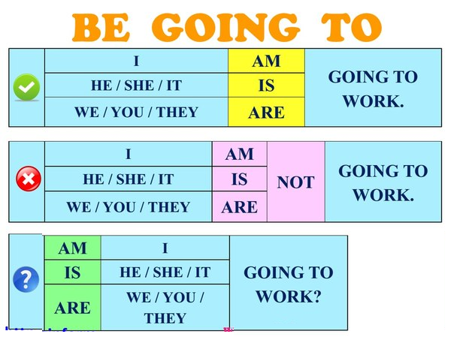

**Future: “Going to”**

“**Going to**” equivale a “**ir a**” en español.

**Structure** *(Estructura)*

1. **Affirmative Sentences** (Frases afirmativas)

**Sujeto + verbo auxiliar (to be) + “going to” + verbo principal.**

**Ejemplos:**

* I **am going to call** you tonight.*(Voy a llamarte esta noche.)*
* She **is going to arrive** late.*(Va a llegar tarde.)*
* They **are going to be** happy to see you.*(Van a estar felices de verte.)*

1. **Negative Sentences** (Frases negativas)

**Sujeto + verbo auxiliar (to be) + “not” + “going to” + verbo principal.**

**Ejemplos:**

* I **am not going to call** you tonight.*(No voy a llamarte esta noche.)*
* She **is not going to arrive** late.*(No va a llegar tarde.)*
* They **are not going to be** happy to see you.*(No van a estar felices de verte.)*

1. **Interrogative Sentences** (Frases interrogativas)

**Verbo auxiliar (to be) + sujeto + “going to” + verbo principal?**

**Ejemplos:**

* **Are** you **going to call** me tonight?*(¿Vas a llamarme esta noche?)*
* **Is** she **going to arrive** late?*(¿Va a llegar tarde?)*
* **Are** they **going to be** happy to see you?*(¿Van a estar felices de verte?)*

1. **Going to: Read and circle the right answer.** Goint to: Lee y encierra en un círculo la alternativa correcta. **(8 points)**

**Hanna’s holidays**

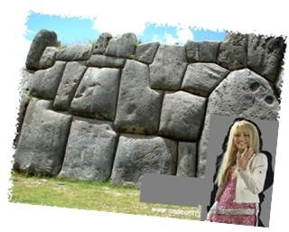Hannah Montana is a famous actress. She is from United States of America and she loves traveling.

Hannah is planning to travel to Cuzco in Peru, she’s going to travel next Friday and she’s going to stay in Peru for three weeks. She’s going to visit Sacsayhuaman and then Machu Picchu. She likes Peruvian culture, and she’s going to eat a delicious Cuzco traditional food. Hannah has friends in Lima; so after Cuzco, she’s going to go there and she is going to visit her friends, too. They live in San Luis and they are going to prepare a big welcome party for Hannah, they love her a lot and they are going to buy a lot of presents for her. After one week, she’s going to travel to Arequipa, she is going to take a lot of

pictures and she’s going to buy some souvenirs and take them back to United States.

1. **Where is Hannah going to travel? (Elige la opción correcta**)
   1. She’s going to travel to Madrid.
   2. She’s going to travel to San Luis.
   3. She’s going to travel to Peru.
   4. She’s going to travel to United States.
2. **What is Hannah going to do in Lima? (Elige la opción correcta**)
3. She’s going to visit Santa Claus.
4. She’s going to buy some souvenirs.
5. She’s going to stay in a hotel.
6. She’s going to go to San Luis.
7. **One of the following alternatives is not correct. (Elige la opción incorrecta)**
   1. She’s going to travel next Friday.
   2. Hannah has friends in Puerto Montt.
   3. She’s going to visit Sacsayhuaman and then Machu Picchu.
   4. She likes Peruvian culture; she’s going to eat traditional food.
8. **One of the following alternatives is correct. (Elige la opción correcta)**
   1. Hannah’s friends live in “San Juan de Miraflores” and they are going to prepare a cake.
   2. She’s not going to visit Sacsaybay and then Machu Picchu.
   3. She’s going to buy some souvenirs and take them back to United States.
   4. Hannah Montana is a famous singer. She is from United Kingdom.
9. **Number the correct sequence of hannah’ plans.** Enumera en qué orden hizo Hannah sus planes 1 a 6. **(6 points)**
10. **________** Hannah’s going to travel to Arequipa
11. **________** Hannah’s going to take a lot of pictures she’s going to buy some souvenirs
12. **________** Hannah’s going to eat a delicious Cuzco traditional food.
13. **________** Hannah’s going to visit her friends
14. **________** Hannah’s going to visit Sacsayhuaman and then Machu Picchu
15. **________** Hannah’s going to travel next Friday
16. **Complete the sentence using the “Formula 1.”** Completa las oraciones usando la “fórmula 1”. Utiliza ls palabras del recuadro, escribe el número de la oración en la imagen que corresponde**. (8 points)**

**Formula 1: is/are + going to + verb**

**swim - visit – drink - eat**

1. They __________________________ New York.
2. She _________________________ her favorite food.
3. The children _______________________ in the pool.
4. The baby ___________________________ the milk.

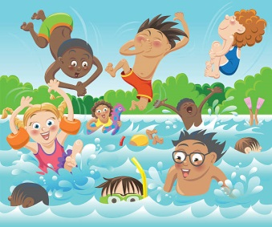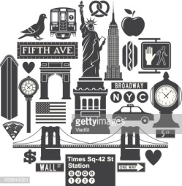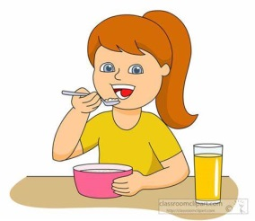

1. **These are my plans for my holiday. Read and match them to the pictures.** Estos son mis planes para vacaciones. Lee las oraciones y escribe el número bajo cada imagen. **(8 points)**
2. **~~I’m going to see my grandparents~~**
3. **I’m going to go to the beach.**
4. **I’m going to do some homework.**
5. **I’m going to eat lots of ice cream.**
6. **I’m going to sleep a lot!.**



|  |  |  |  |  |
| --- | --- | --- | --- | --- |
|  | **A** |  |  |  |

1. **Vocabulary: Translate each word into Spanish.** Vocabulario: Traduce las siguientes palabras al español utilizando tu diccionario. **Con letra clara escribe los nombres en español *(6 points)***

|  |  |
| --- | --- |
| **English** | **Spanish** |
| 1. **Backpack** |  |
| 1. **Campground** |  |
| 1. **Foreign** |  |
| 1. **Hiatus** |  |
| 1. **Hostel** |  |
| 1. **Holiday** |  |

1. **Transport and traveling: Read and circle the right answer.** Transportes y viajes: Lee y encierra en un círculo la alternativa correcta. **(13 points)**
2. **A person whose job is to serve and take care of passengers on an aircraft:**



* 1. Flight assessment
  2. Flight attendant
  3. Flight sergeant

1. **A comfortable bus for carrying passengers over long distances:**

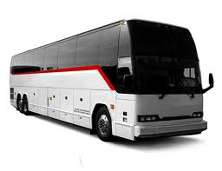

* 1. Couch
  2. Carriage
  3. Coach

1. **A place where taxis park while they are waiting for passengers:**

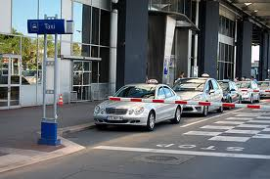

1. Taxi ring
2. Taxi lone
3. Taxi rank
4. 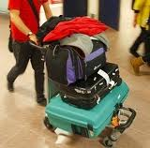**A small vehicle at the airport that can be pushed and is used for carrying the luggage:**
   1. Pedalo
   2. Trolley
   3. Pram
5. **A person walking in the street and not travelling in a vehicle:**

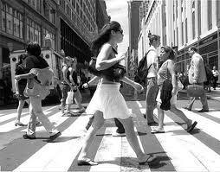

* 1. Pedestrian
  2. Pedometer
  3. Pedant

1. **A sum of money that must be paid as punishment for parking illegally:**

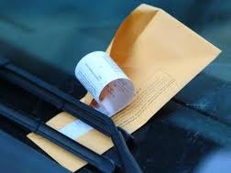

* 1. Parking bill
  2. Parking fine
  3. Parking receipt

1. 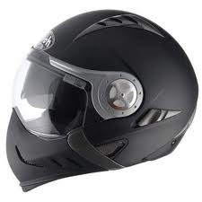**A hat made of very strong material worn when riding a motorcycle to protect your head:**
   1. Armour
   2. Helmet
   3. Beaver hat
2. **A place where roads meet, forming a circle that all traffic must go around in the same direction:**

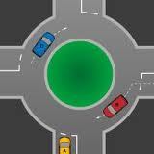

* 1. Merry-go-round
  2. Roundabout
  3. Rounders

1. 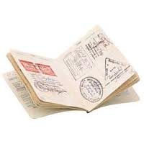**A stamp or mark put in your passport by officials of a foreign country, which permits you to enter their country:**
   1. Vice
   2. Visa
   3. Vista
2. **The flat area at a train station where you get on or off the train:**

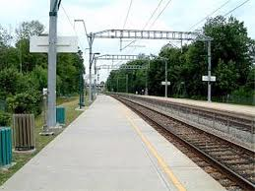

* 1. Runway
  2. Platform
  3. Deck

1. 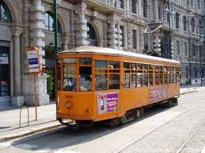 **A vehicle driven by electricity that runs on rails along the streets and carries passengers:**
2. Tramp
3. Tram
4. Trap
5. **The part of a train where you can buy something to eat and drink:**

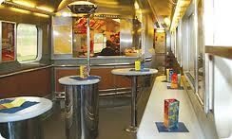

1. Canteen car
2. Buffet car
3. Gorging car
4. **A part of a road that only bicycles are allowed to use:**

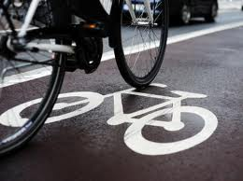

1. Cycle path
2. Cycle line
3. Cycle lan
4. **Match the sentences to their corresponding pictures.** Escribe en el recuadro de la imagen la letra de la oración correcta. **(6 points)**
   1. **She went to the library on foot.**
   2. **You have to get on a bus at the bus station.**
   3. **Take a train and get off at Venice Station.**

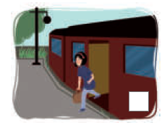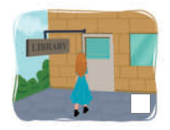

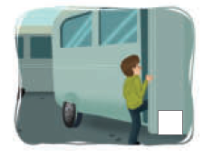

1. **Match the sentences with their corresponding pictures.** Lee cada oración y observa las imágenes (a,b,c y d). En el recuadro debes escribir la letra de la imagen que corresponde. **(8 points)**

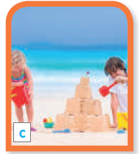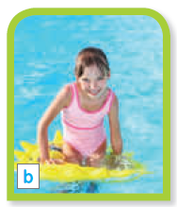

1. We like to build castles with sand.
2. There is a shell in his hand.
3. When I go to the pool, I wear my swimsuit.
4. She is protecting her skin from the sun with sunblock lotion.