**GUIA PEDAGÓGICA N° 15**

**PLAN DE APRENDIZAJE REMOTO**

|  |  |  |  |
| --- | --- | --- | --- |
| **Nombre del estudiante:** |  | | |
| **Profesor(a):** | **Paola Véliz Herrera** | | |
| **Correo electrónico** | **paolaveliz.jlp@gmail.com** | **Puntaje total:** | **59 puntos.** |
| **Curso:** | **5° Básico** | **Asignatura:** | **Inglés** |
| **Fecha de envío:** | **30/10/2020** | **Fecha de recepción:** | **30/11/2020** |

|  |  |
| --- | --- |
| **Unidad N° 4** | **What´s the Weather Like?** |
| **Objetivo/s general/es:**  **OA1 - OA5 - OA12 - OA14** | **Clothes and sport equipment.**  - Responden preguntas asociadas a palabras clave y vocabulario temático.  - Identifican tema de los textos escuchados con el apoyo de imágenes, palabras y frases clave.  **-** Identifican ideas generales del texto escuchado con el apoyo de imágenes y preguntas de información simples.  **-** Responden preguntas de información (Who? Where? When?) asociadas a personas, lugares y tiempo. |
| **Instrucciones** | * Respetar la fecha de entrega para las actividades. * Cualquier duda, enviar un correo electrónico a la docente. * Necesitará lápices, hojas en algunos casos, y **diccionario**, ya sea en línea o físico. |

1. **Reading comprehension: Read and circle the right answer**. Comprensión de lectura: Lee y encierra en un círculo la alternativa correcta (**10 points)**

**Clothes**

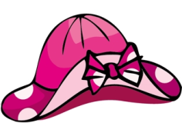Clothing is something we all should wear in order to fit in to society. The act of wearing clothing is a choice in some indigenous societies while in a more modern culture you could find yourself in trouble with the police if you choose not to wear clothes. Clothes are easily accessible and can be bought in most high street shops. Supermarkets are also beginning to sell clothes. Clothes are for keeping people warm or serving as protection from the strong burning sun. Certain items of clothing can be expensive, especially if it is made by a well-known brand or is a particular design. While clothing is affordable for most people, the price usually depends on the quality of the material used to make the item and its brand name. In most countries clothing is taxed, while food is not. This is probably because clothing can be considered as a luxury item, especially if it is of very good quality.

The type of clothing that is worn usually depends on the occasion. People that attend a wedding usually wear formal clothes. Men often wear suits and women wear dresses. Formal and smart clothing is often worn in times of celebration. People often wear different clothing at work. Some jobs require people to wear a special uniform which should be worn by all employees. A pilot, doctor or air hostess may be required to wear a uniform so that all the staff can be easily recognized. Other jobs are less strict and may allow people to wear casual clothes. Construction workers are usually asked to wear protective clothing, especially when the site is considered highly dangerous.

People often choose to wear comfortable clothing inside their own home. This choice of clothing may be very different to the clothing they would normally wear outside. Some people even stay in their bedclothes all day on the weekend when they plan to relax and not go anywhere. People often wear clothing which matches their current state of health or their age. Pregnant women are likely to wear baggy clothes, while youths often wear tighter clothing to show their figure. Younger females often wear high heeled shoes while elderly people tend to wear more comfortable shoes which will allow them to walk with ease.

**Reading comprehension questions that go with the above reading passage.**

**Principio del formulario**

1. **When can items of clothing be expensive?**
2. When they are from the supermarket.
3. When they are taxed too much.
4. When it is a well-known brand or design.
5. When they are in the sale.
6. **What kind of job requires workers to wear protective clothing?**
7. Pilots
8. Construction workers
9. Doctors
10. Air hostess
11. **How do some youths usually like to wear their clothes?**
12. Baggy
13. Tight
14. Short
15. Long
16. **What type of clothing is worn in times of celebration?**
17. Formal
18. Casual
19. Protective
20. Bedclothes
21. **Who is more likely to wear baggy clothing?**
22. Youths
23. Workers
24. Pregnant ladies
25. Elderly people

Final del formulario

**Picture Dictionary**

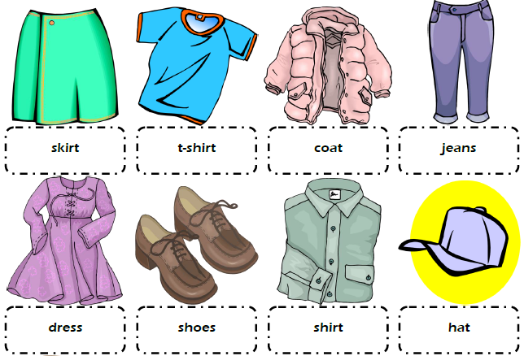

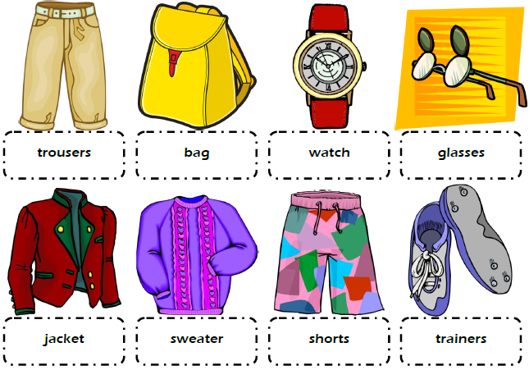

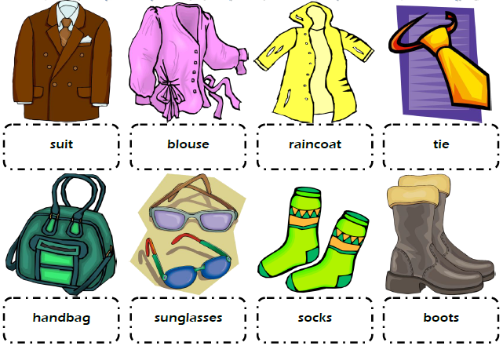

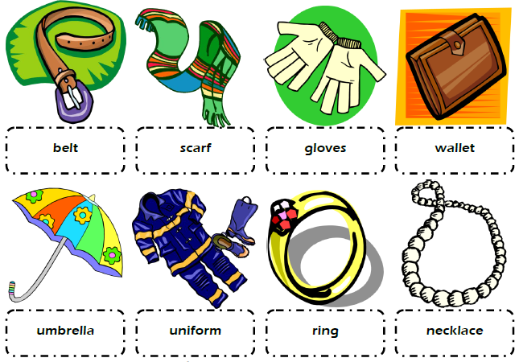

1. **Clothes and accessories: Look at the picture, circle and choose the correct answer**. Vestimentas y accesorios: Observa las imágenes, encierra en un círculo la alternativa correcta **(24 points)**

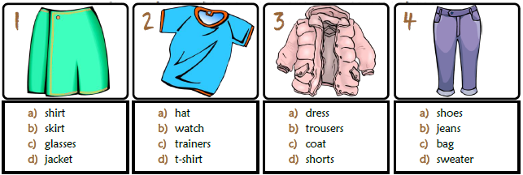

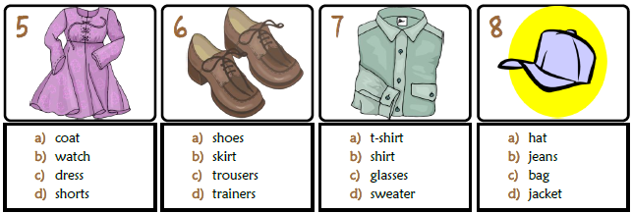

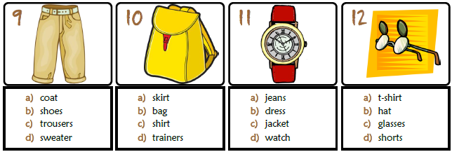

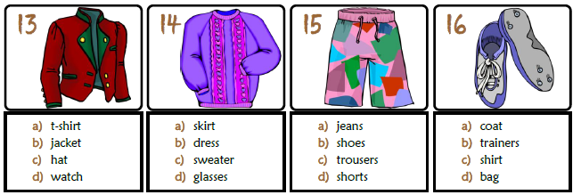

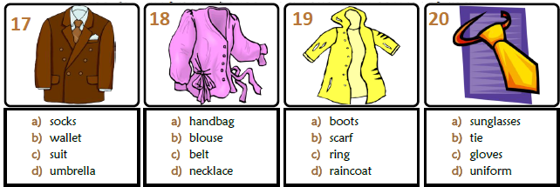

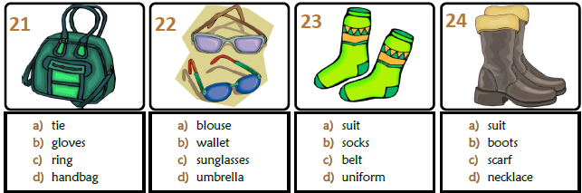

1. **Vocabulary: Translate each word into Spanish.** Vocabulario: Traduce las siguientes palabras al español utilizando tu diccionario. **Con letra clara escribe los nombres en español *(6 points)***

|  |  |
| --- | --- |
| **English** | **Spanish** |
| 1. **Tie:** |  |
| 1. **Handbag:** |  |
| 1. **Sunglasses:** |  |
| 1. **Socks:** |  |
| 1. **Scarf:** |  |
| 1. **Necklace:** |  |

**Wh Questions**

**Wh Questions** son un grupo de preguntas que se caracterizan porque en su nombre tienen las letras "wh-" al inicio, excepto por uno de sus casos (how). Las ***Wh Questions*** son:

* **What**: qué o cuál
* **Why**: por qué
* **When**: cuándo
* **Where**: dónde
* **Who**: quién
* **Which**: cuál
* **How**: cómo

En esta clase solo trabajaremos con who, where y when

**Who:**

Este pronombre lo utilizas para referirte al sujeto de la oración, es decir, a quien realiza la acción, por ejemplo:

* ***Who makes the final decision?***¿Quién toma la decisión final?
* **My boss is the person who makes the final decision*.***  
  Mi jefe es la persona quien toma la decisión final.
* **Who is coming to the party? (He is.)**

*¿****Quién****va a venir a la fiesta?*

* **Who ate all of my cake? (He did.)**

*¿****Quién****se comió todo mi pastel?*

* **Who is David Cameron? (He is.)**

*¿****Quién****es David Cameron?*

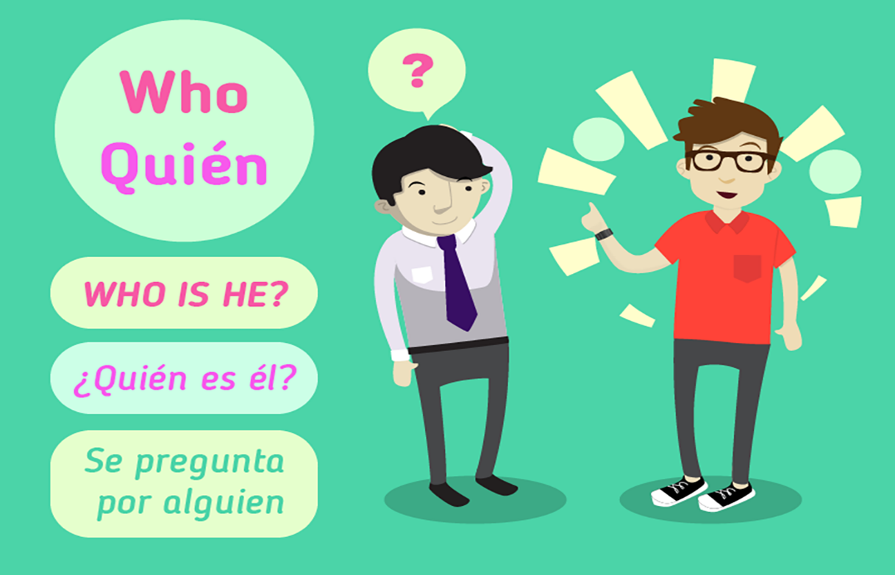

**Where:**

**Where** lo traduciremos como ‘dónde’. De ahí que se usará para **saber el lugar donde está algo o bien, para las localizaciones**. De nuevo, la estructura en la frase mantiene el mismo orden de auxiliar, sujeto y el verbo principal de la misma.

* **Where were you born?** – ¿Dónde naciste?. Es una de las primeras frases que nos dan a conocer sobre cómo usar el adverbio **interrogativo Where**, por lo que, a partir de ella podremos formular todas las que necesitamos, recordando su posición en la frase.
* **Where are my shoes?** – ¿Dónde están mis zapatos?
* **Where do you live?** – ¿Dónde vives?.
* **Where did he buy the tickets?** – ¿Dónde compró las entradas?.

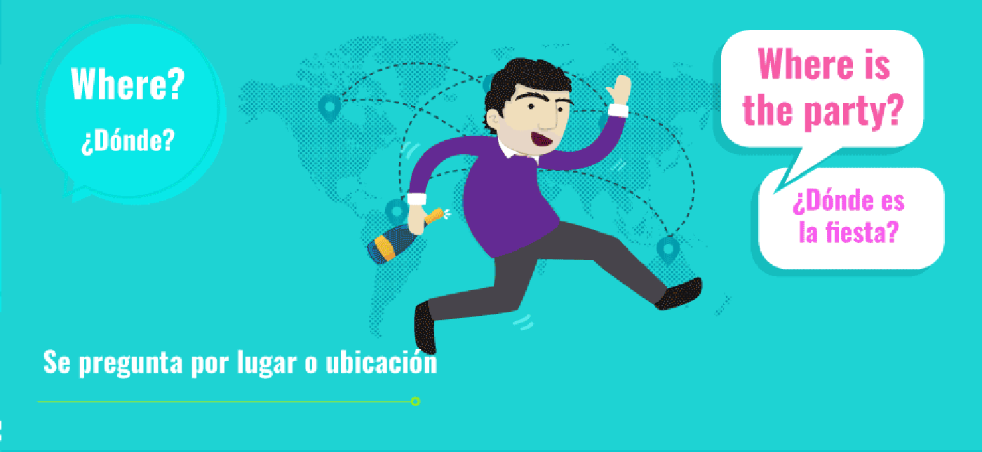

**When:**

En primer lugar, **When se traduce por el adverbio ‘cuándo’**. Por lo que ya nos indica que servirá para preguntar acerca del tiempo o de una ocasión concreta en él. Si quieres saber una fecha o bien, cuándo sucede algo, necesitas usar ‘When’.

* When is your birthday? – ¿Cuándo es tu cumpleaños?
* When do the shops open? – ¿Cuándo abren las tiendas?.
* When did happen the accidente? – ¿Cuándo ocurrió el accidente?.

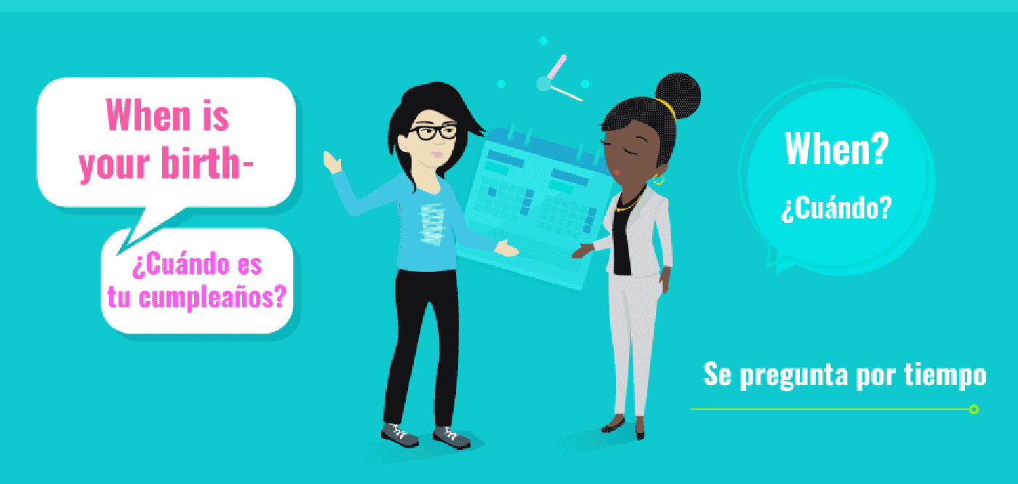

1. **Write in English the following sentences in Spanish.** Escriben en inglés las siguientes oraciones que se encuentran en español **debes utilizar who, where y when. (7 points)**
2. **¿Quién va a venir a la fiesta?**

**English:** ________________________________________________?

1. ¿**Quién se comió todo mi pastel?**

**English:** ________________________________________________?

1. **¿Quién es David Cameron?**

**English:** ________________________________________________?

1. **¿Dónde naciste?.**

**English:** ________________________________________________?

1. **¿Dónde compró las entradas?.**

**English:** ________________________________________________?

1. **¿Cuándo es tu cumpleaños?**

**English:** ________________________________________________?

1. **¿Cuándo ocurrió el accidente?.**

**English:** ________________________________________________?

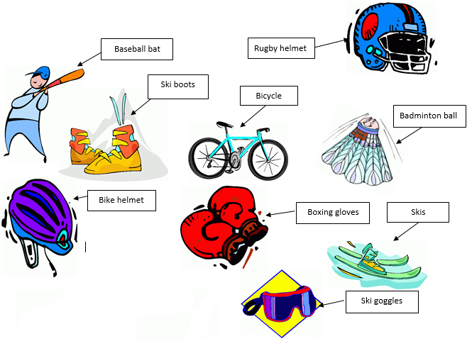**Sports equipment vocabulary. Enlace de ayuda: https://www.espressoenglish.net/english-vocabulary-words-sports-equipment/**

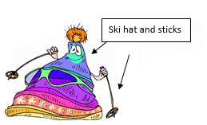

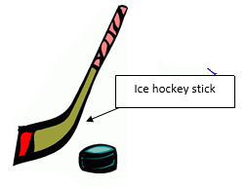

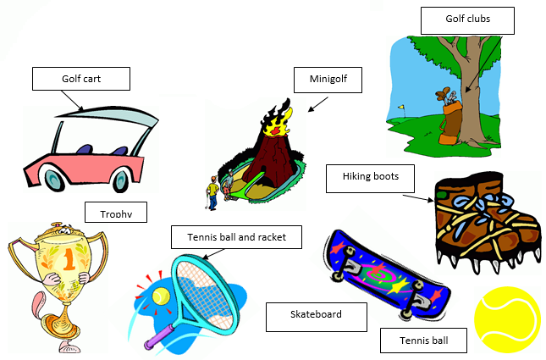

1. **Sport equipment: Read and circle the right answer.** Equipamiento deportivo: Lee las oraciones y encierra en un círculo la oración correcta. **(12 points)**
2. The piece of wood used for hitting the ball in baseball or cricket:

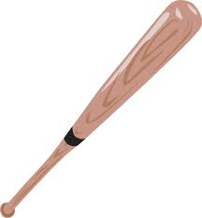

1. racket
2. bat
3. log
4. 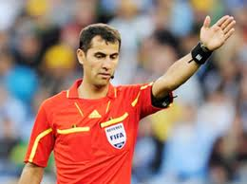The official who controls the game in some sports, e.g. football is called:
5. judgments
6. referee
7. judge
8. 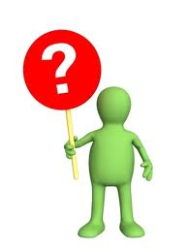When a game is finished without either team winning, e.g. 1-1, the game ends in a:
9. draw or tie
10. drowning
11. art
12. 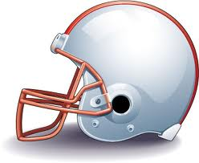A type of hard hat that protects the head of the players in some sports is:
13. an armour
14. a Rugby helmet
15. a bowler hat
16. 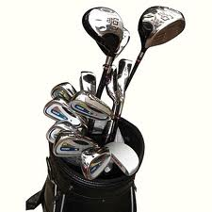The long metal stick used for hitting the ball in golf:
17. golf club
18. golf batting
19. golf ironing
20. Who trains a person or team in sport is the:

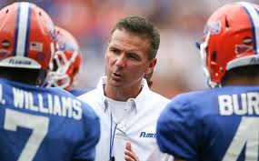

1. trainee
2. coach
3. couch
4. The leader of a sports team is the:
5. boss
6. captain
7. commander
8. 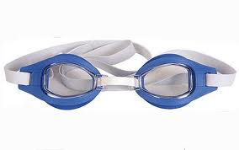The pair of glasses that fit closely to the face to protect your eyes from water in swimming:
9. google
10. goggles
11. goblins
12. The number 0, especially as the score in some games is called:
13. nil
14. variety
15. selection
16. 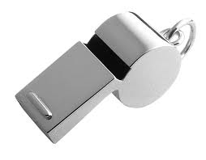A small metal or plastic tube that you blow to make a sound to attract the players’ attention:
17. whisper
18. whistle
19. whisker
20. The sticks used to push yourself forward while skiing:

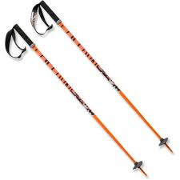

1. ski bats
2. ski posts
3. ski poles
4. 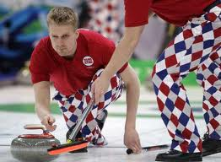A game played on ice, in which players slide heavy flat stones towards a mark:
5. curling
6. cordoning
7. pushing